**Project Development Phase**

**Delivery of Sprint 1**

|  |  |
| --- | --- |
| **DATE** | 29 October 2022 |
| **TEAM ID** | PNT2022TMID24193 |
| **PROJECT NAME** | Inventory Management System for Retailers |

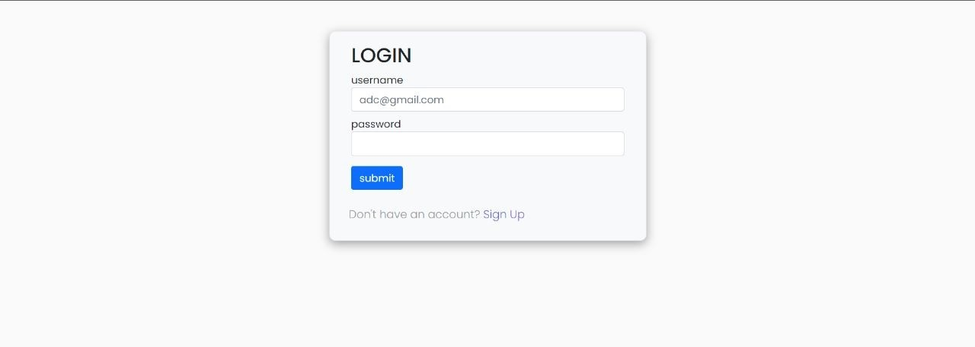**Registration:**

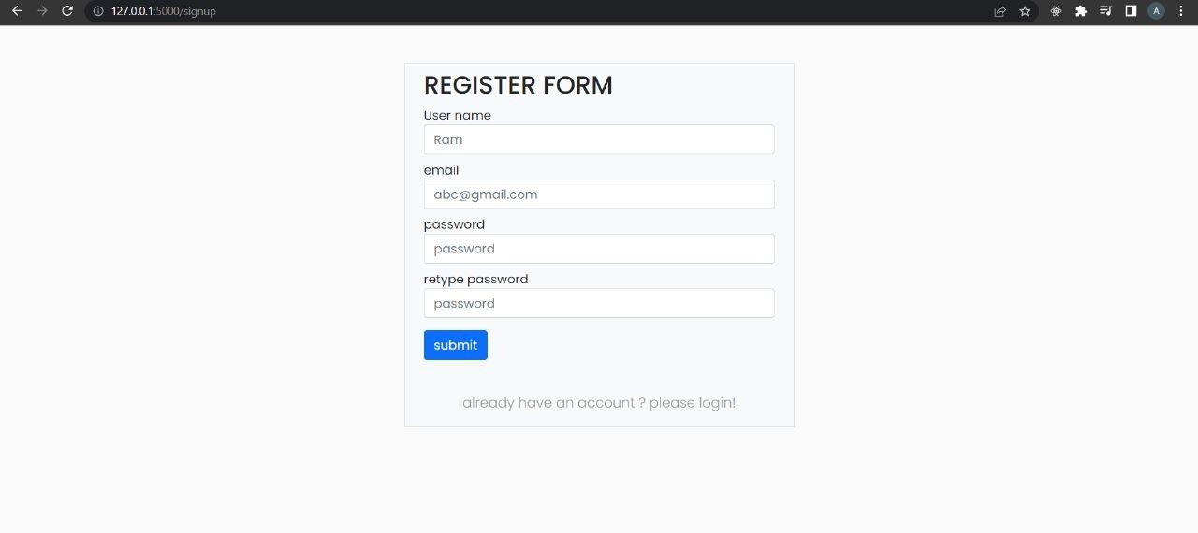

**Login:**

**Confirmation Email:**

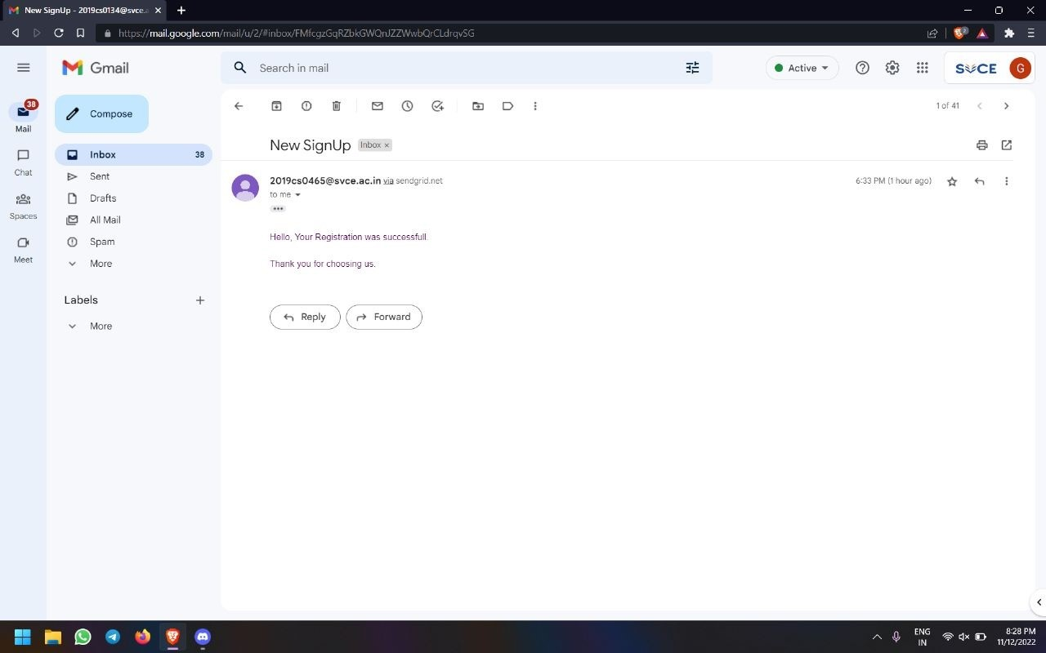

**Dashboard:**

